**USA Softball of Metro Detroit**



## 2023 Timothy J. Doyle

## Community Grant Program

**General Information Sheet**

***Who:***

Eligibility is open to any USA Softball of Metro Detroit registered community/agency. The metro Detroit area consists of Wayne, Oakland, Macomb, and Livingston counties. Community must have been part of the USA Softball of Metro Detroit program for at least two (2) years prior to application submittal (2021 and 2022). Communities receiving a grant the previous year (2021) are ineligible to apply for another grant until next year. If awarded a grant, the improvement project must be completed during the period of July 1, 2023 to June 30, 2024

***What:***

Grants up to $5000 will be awarded annually to a USA Softball of Metro Detroit community softball programs to enhance the quality of softball in our area. Amount of individual grants will depend on number of applications, proposed amounts, and the potential to improve the quality of softball with the proposed project.

***When:***

Applications are due January 5, 2023. The USA Softball of Metro Detroit board will select winning projects at its next bimonthly meeting. Applicants will be notified no later than early February. Upon approval, a signed agreement with USA Softball of Metro Detroit is mandatory to set project payment(s) schedule.

***Where:***

E-mail the completed application to:

Sterling Heights Parks and Recreation

Attn: Kyle Langlois

Email: [klanglois@sterling-heights.net](mailto:klanglois@sterling-heights.net)

***Questions:***

Contact Kyle Langlois at 586.446.2705 or at the e-mail address listed above.

Application is available on the USA Softball of Metro Detroit web site at **www.USASoftballDetroit.org**

.

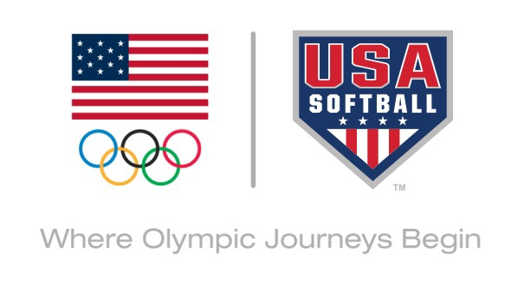



# 2023 USA Softball of Metro Detroit

# Grant Application

Deadline – January 5, 2023

Please fill out completely

**Community/Agency** **Contact**

**Address** **City** **Zip**

**Phone** **Fax** **E-Mail**

**Years affiliated with USA Softball of Metro Detroit** **New  ___ years**

**Does your Community register?**

**Adult Teams** **Yes Youth Teams** **Yes Umpires** **Yes**

**No** **No** **No**

**Project Name** **Project Location:**

**Project Start Date:** **Project Completion Date:**

**Amount Requested; $****Percentage of total project cost:****%**

**($250 - $5000)**

**Project Description (Please attach an explanation of the project scope and how the project will enhance your softball program; attach photos and any other supporting documents you feel may be beneficial to the decision process).:**

**Is the proposed project completion dependant on receiving of the total amount of the grant request?** **Yes** **No**

**Does the project need to be approved by your city council or local governing body?       Yes       No**



